**Resource classes**

-Resource classes are pre-determined resource limits in Synapse SQL pool that govern compute resources and concurrency for query execution.

-The resource class of the service administrator is fixed at smallrc and cannot be changed. The service administrator is the user created during the provisioning process.

-Resource classes are implemented by assigning users to database roles. When a user runs a query, the query runs with the user's resource class:

* To add role: EXEC sp_addrolemember 'largerc', 'loaduser';
* To drop role: EXEC sp_droprolemember 'largerc', 'loaduser';

(Where largerc = resource class & loaduser = user,

sp_addrolemember & sp_droprolemember are commands to add & drop user to a resource class)

**Workload Management**

Creation of Workload Management over dedicated sql pool.

Steps:

* Create Synapse Workspace.
* Create Sql Dedicated Pool.
* In master of dedicated pool Create login for new user.
* In master of dedicated pool grant permissions to the newly added user.
* Open dedicated sql pool and under workload management create new workload group.
* Add isolations/resource reservation to group.
* Add classifiers to group.

Some ss of the same:

(step 3&4)

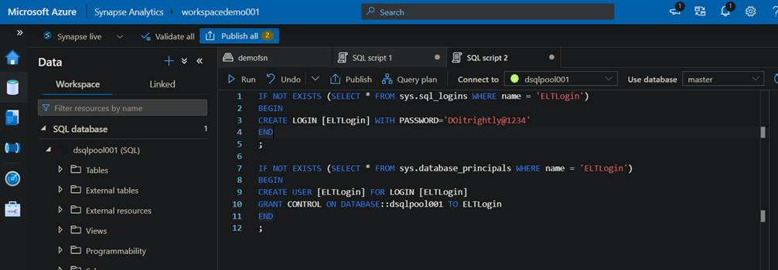

(step 5,6,7)

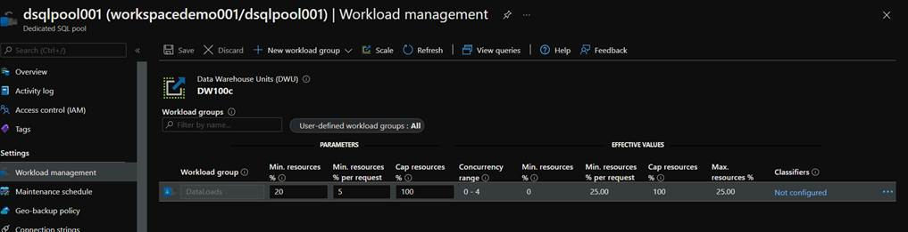

LENNO-2

Deploy to CA: 25-Feb onwards Deploy to other regions

1. Customers can enable enhanced metadata feature as

2. Enable support for derived tables types such as DirPer

3. Trigger auto-reinitialize when more than half the reco

4. Metadata update performance improvements (Decou

5. Reliability improvements in the service (less and less e

LENNO-2

Deploy to CA: 25-Feb onwards Deploy to other regions : 14

Customers can enable enhanced metadata feature as a

Enable support for derived tables types such as DirPerso

Trigger auto-reinitialize when more than half the records

Metadata update performance improvements (Decouple

2.

3.

4.

5. Reliability improvements in the service (less and less erre

1.

LENNO-2

Deploy to CA: 25-Feb onwards Deploy to other regions : 14

Customers can enable enhanced metadata feature as a

Enable support for derived tables types such as DirPerso

Trigger auto-reinitialize when more than half the records

Metadata update performance improvements (Decouple

2.

3.

4.

5. Reliability improvements in the service (less and less erre

1.